Heptagon

Definition
# Source: AI Source: Provided by: [Data Path: Persons Table -> ID Column: 1, Name_En Column: Motasem Essam] -> From: [ChatGPT] on [7/25/2026]
A heptagon is a polygon with seven sides, seven vertices, and seven interior angles.
The name comes from Greek:
- hepta = seven
- gonia = angle
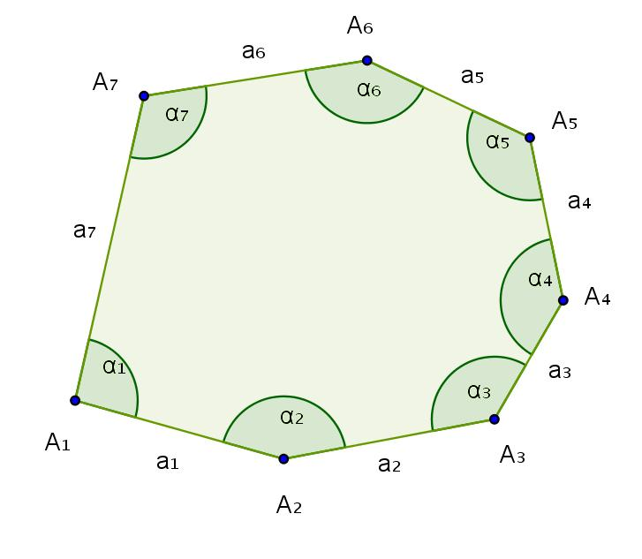
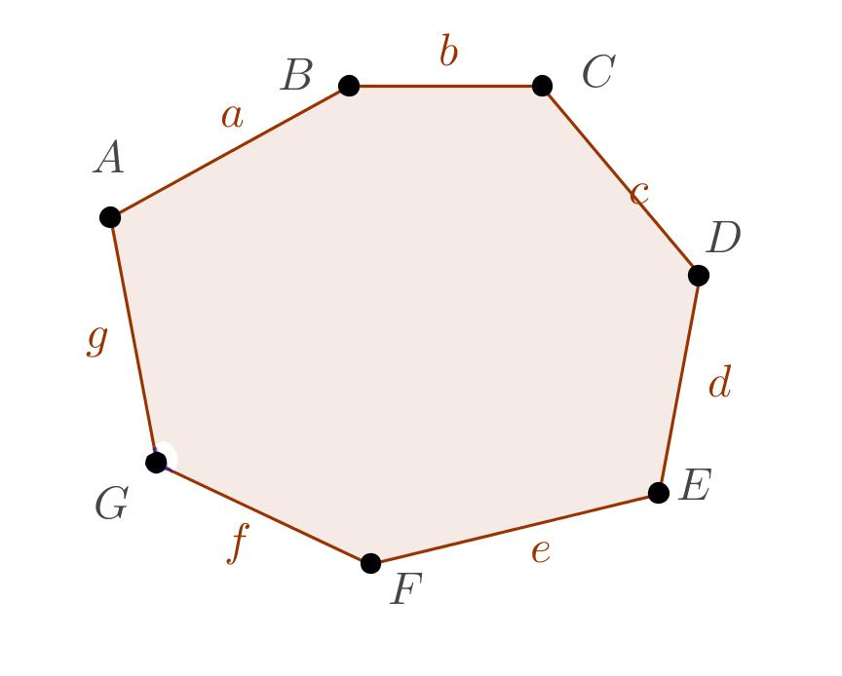
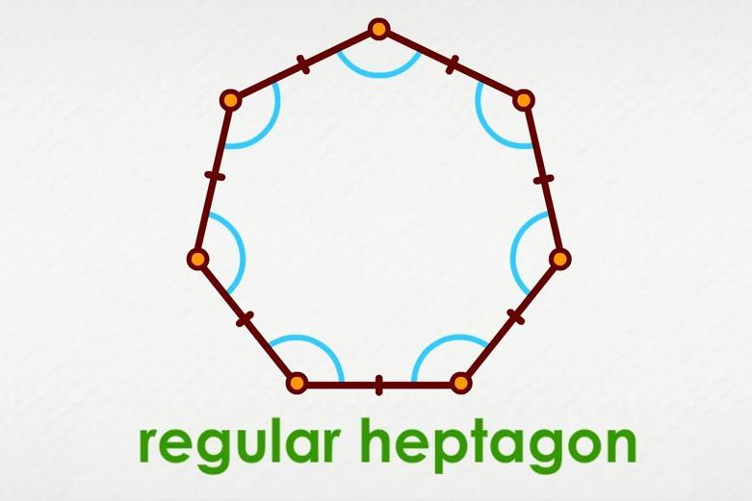
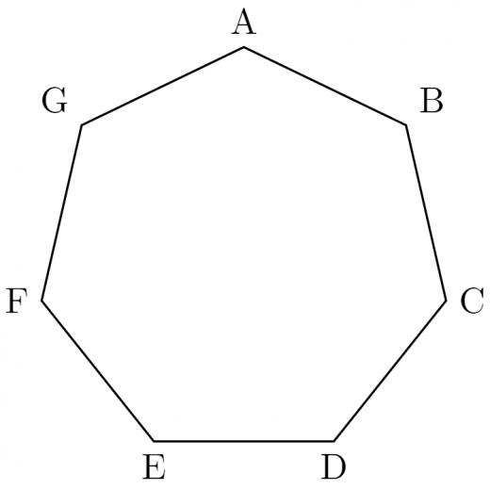
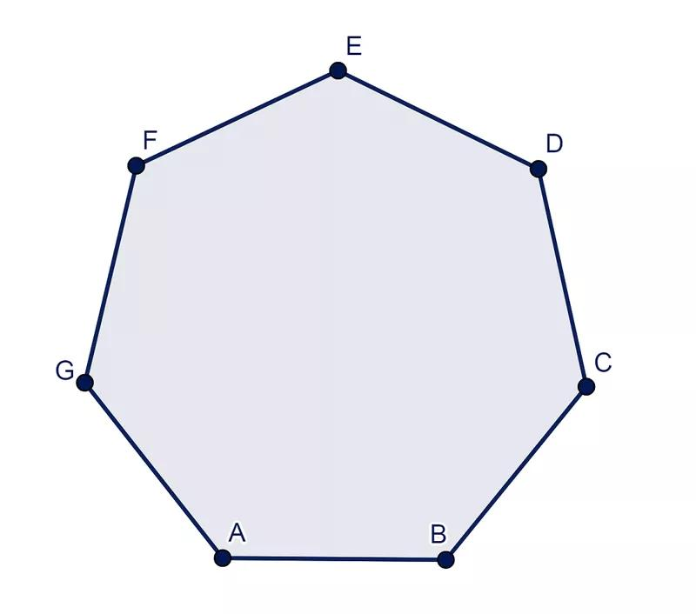

Fundamental Elements
# Source: AI Source: Provided by: [Data Path: Persons Table -> ID Column: 1, Name_En Column: Motasem Essam] -> From: [ChatGPT] on [7/25/2026]
A heptagon can be labeled:
$$\boxed{ABCDEFG}$$
Its seven sides are:
$$\overset{‾}{AB}, \overset{‾}{BC}, \overset{‾}{CD}, \overset{‾}{DE}, \overset{‾}{EF}, \overset{‾}{FG}, \overset{‾}{GA}$$
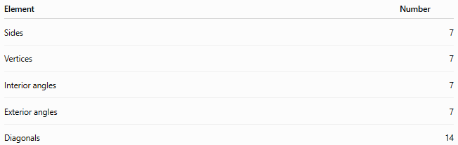
Element | Number
Sides | 7
Vertices | 7
Interior angles | 7
Exterior angles | 7
Diagonals | 14

Classification of Heptagons
# Source: AI Source: Provided by: [Data Path: Persons Table -> ID Column: 1, Name_En Column: Motasem Essam] -> From: [ChatGPT] on [7/25/2026]
Heptagons can be classified according to different geometric properties.
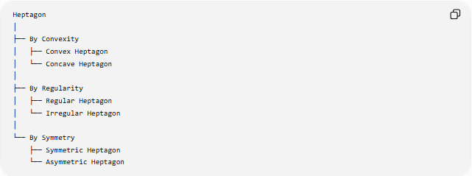
Heptagon
│
├── By Convexity
│ ├── Convex Heptagon
│ └── Concave Heptagon
│
├── By Regularity
│ ├── Regular Heptagon
│ └── Irregular Heptagon
│
└── By Symmetry
├── Symmetric Heptagon
└── Asymmetric Heptagon

1. Classification by Convexity

1.1 Convex Heptagon
# Source: AI Source: Provided by: [Data Path: Persons Table -> ID Column: 1, Name_En Column: Motasem Essam] -> From: [ChatGPT] on [7/25/2026]
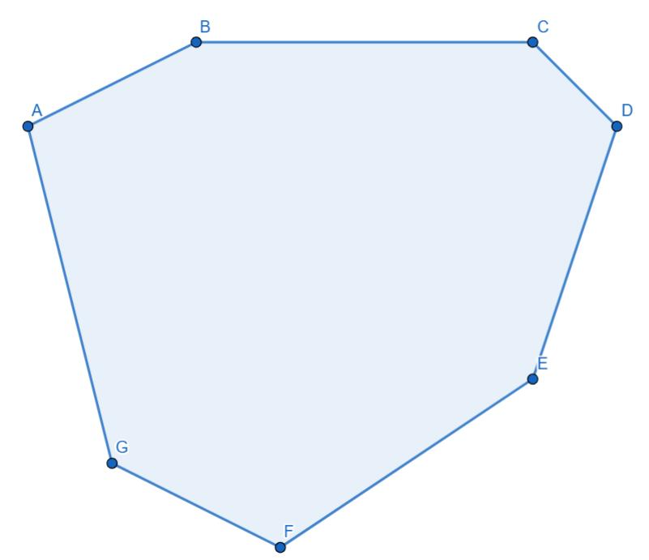
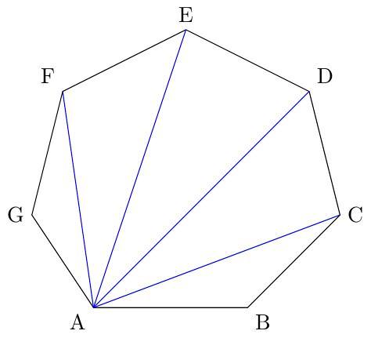
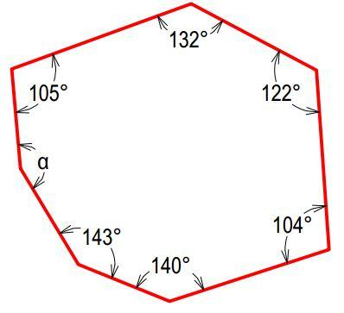
Definition
A convex heptagon is a heptagon in which every interior angle is less than ${180}^{∘}$.
$$\boxed{0^{∘}<∠A<{180}^{∘}}$$
for every interior angle.
Main Properties
- All seven vertices point outward.
- It has no inward indentation.
- Every diagonal lies completely inside the heptagon.
- Its interior-angle sum is ${900}^{∘}$.

1.2 Concave Heptagon
# Source: AI Source: Provided by: [Data Path: Persons Table -> ID Column: 1, Name_En Column: Motasem Essam] -> From: [ChatGPT] on [7/25/2026]
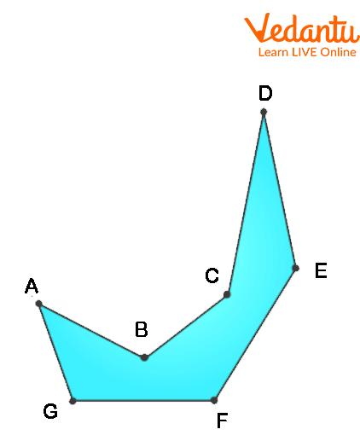
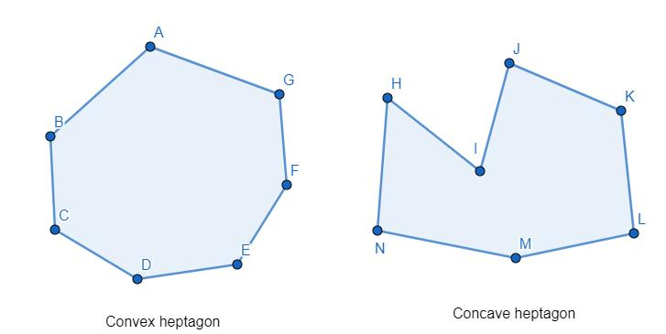
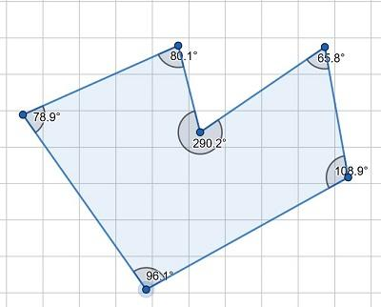
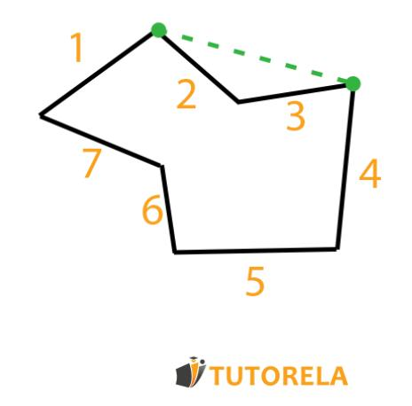
Definition
A concave heptagon is a heptagon with at least one interior angle greater than ${180}^{∘}$.
$$\boxed{{180}^{∘}<∠A<{360}^{∘}}$$
for at least one interior angle.
Main Properties
- It has at least one inward-pointing vertex.
- It has an indentation.
- At least one diagonal lies partly outside the heptagon.
- It is not convex.

2. Classification by Regularity

2.1 Regular Heptagon
# Source: AI Source: Provided by: [Data Path: Persons Table -> ID Column: 1, Name_En Column: Motasem Essam] -> From: [ChatGPT] on [7/25/2026]
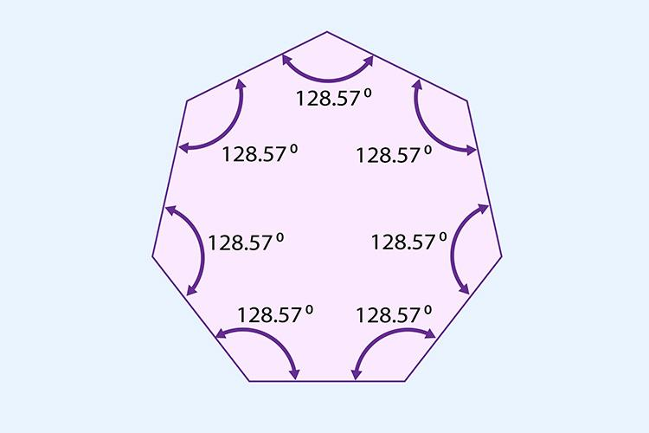
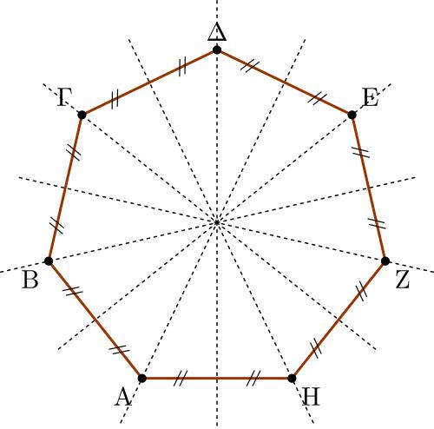
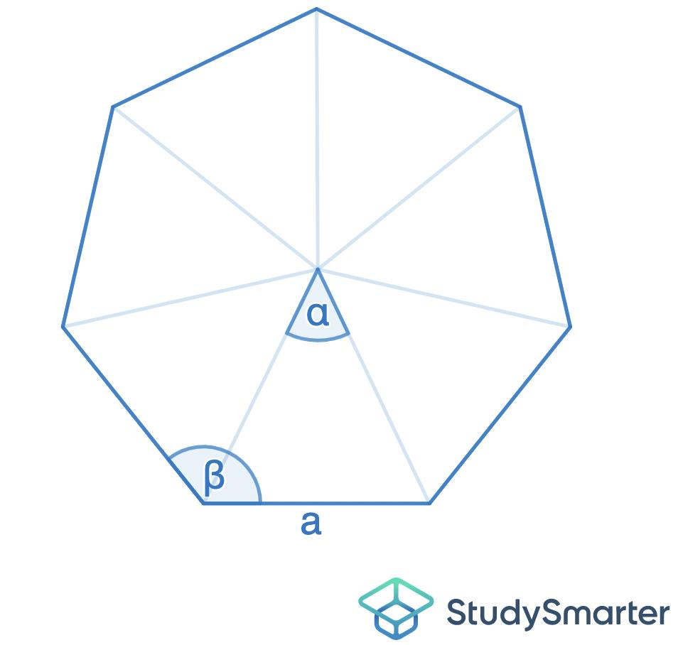
Definition
A regular heptagon is a heptagon in which:
- all seven sides are congruent;
- all seven interior angles are congruent.
If the side length is $a$:
$$\boxed{AB=BC=CD=DE=EF=FG=GA=a}$$
Interior Angle
The sum of the interior angles is:
$$\left(7-2\right)×{180}^{∘} \\ =5×{180}^{∘} \\ \boxed{{900}^{∘}}$$
Therefore, each interior angle is:
$$\frac{{900}^{∘}}{7} \\ \boxed{{\frac{900}{7}}^{∘}≈{128.57}^{∘}}$$
Exterior Angle
Each exterior angle is:
$$\frac{{360}^{∘}}{7} \\ \boxed{{\frac{360}{7}}^{∘}≈{51.43}^{∘}}$$
Central Angle
For a regular heptagon:
$$\boxed{\frac{{360}^{∘}}{7}≈{51.43}^{∘}}$$
Perimeter
$$\boxed{P=7a}$$
Symmetry
A regular heptagon has:
$$\boxed{7}$$
lines of symmetry and rotational symmetry of order:
$$\boxed{7}$$

2.2 Irregular Heptagon
# Source: AI Source: Provided by: [Data Path: Persons Table -> ID Column: 1, Name_En Column: Motasem Essam] -> From: [ChatGPT] on [7/25/2026]
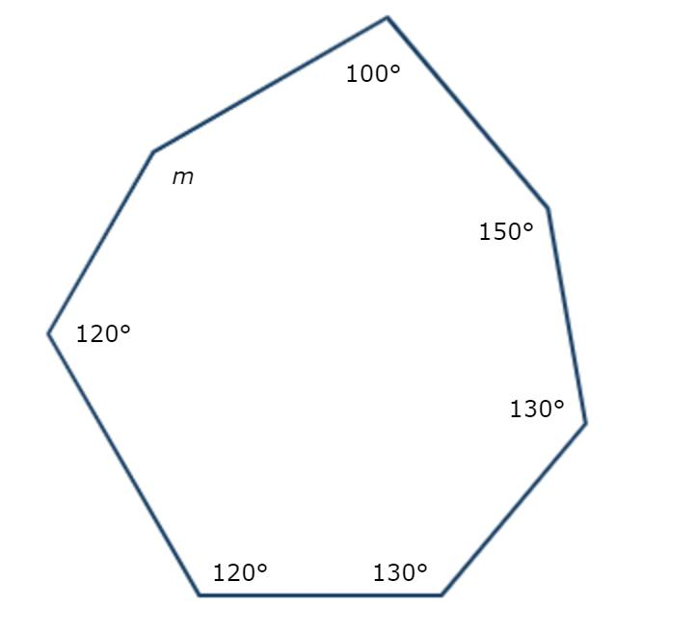
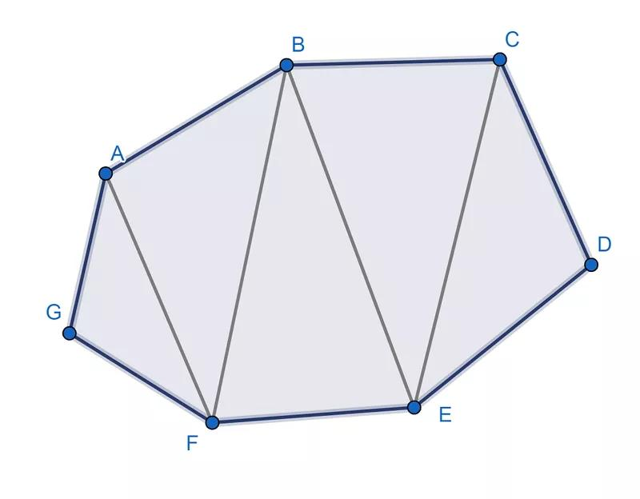
Definition
An irregular heptagon is a heptagon that does not have all seven sides and all seven interior angles equal.
It may have:
- unequal side lengths;
- unequal interior angles;
- some symmetry;
- no symmetry.
An irregular heptagon can be either convex or concave.
Irregular Heptagon
├── Irregular Convex Heptagon
└── Irregular Concave Heptagon

3. Classification by Symmetry

3.1 Symmetric Heptagon
# Source: AI Source: Provided by: [Data Path: Persons Table -> ID Column: 1, Name_En Column: Motasem Essam] -> From: [ChatGPT] on [7/25/2026]
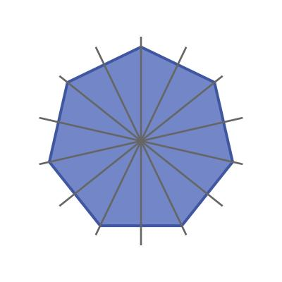
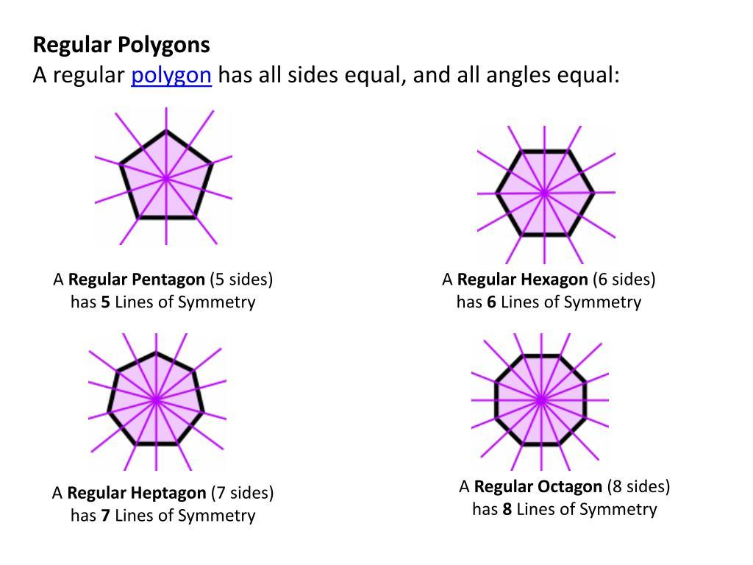
Definition
A symmetric heptagon has at least one form of geometric symmetry, such as reflection symmetry or rotational symmetry.
A regular heptagon has:
$$\boxed{7\text{ lines of symmetry}}$$
and rotational symmetry of order:
$$\boxed{7}$$
Important Note
A symmetric heptagon does not necessarily have to be regular.
An irregular heptagon may have one or more lines of symmetry.

3.2 Asymmetric Heptagon
# Source: AI Source: Provided by: [Data Path: Persons Table -> ID Column: 1, Name_En Column: Motasem Essam] -> From: [ChatGPT] on [7/25/2026]
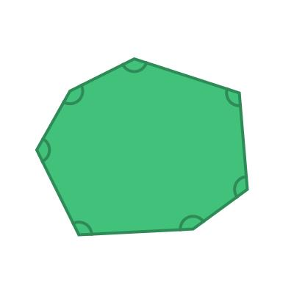
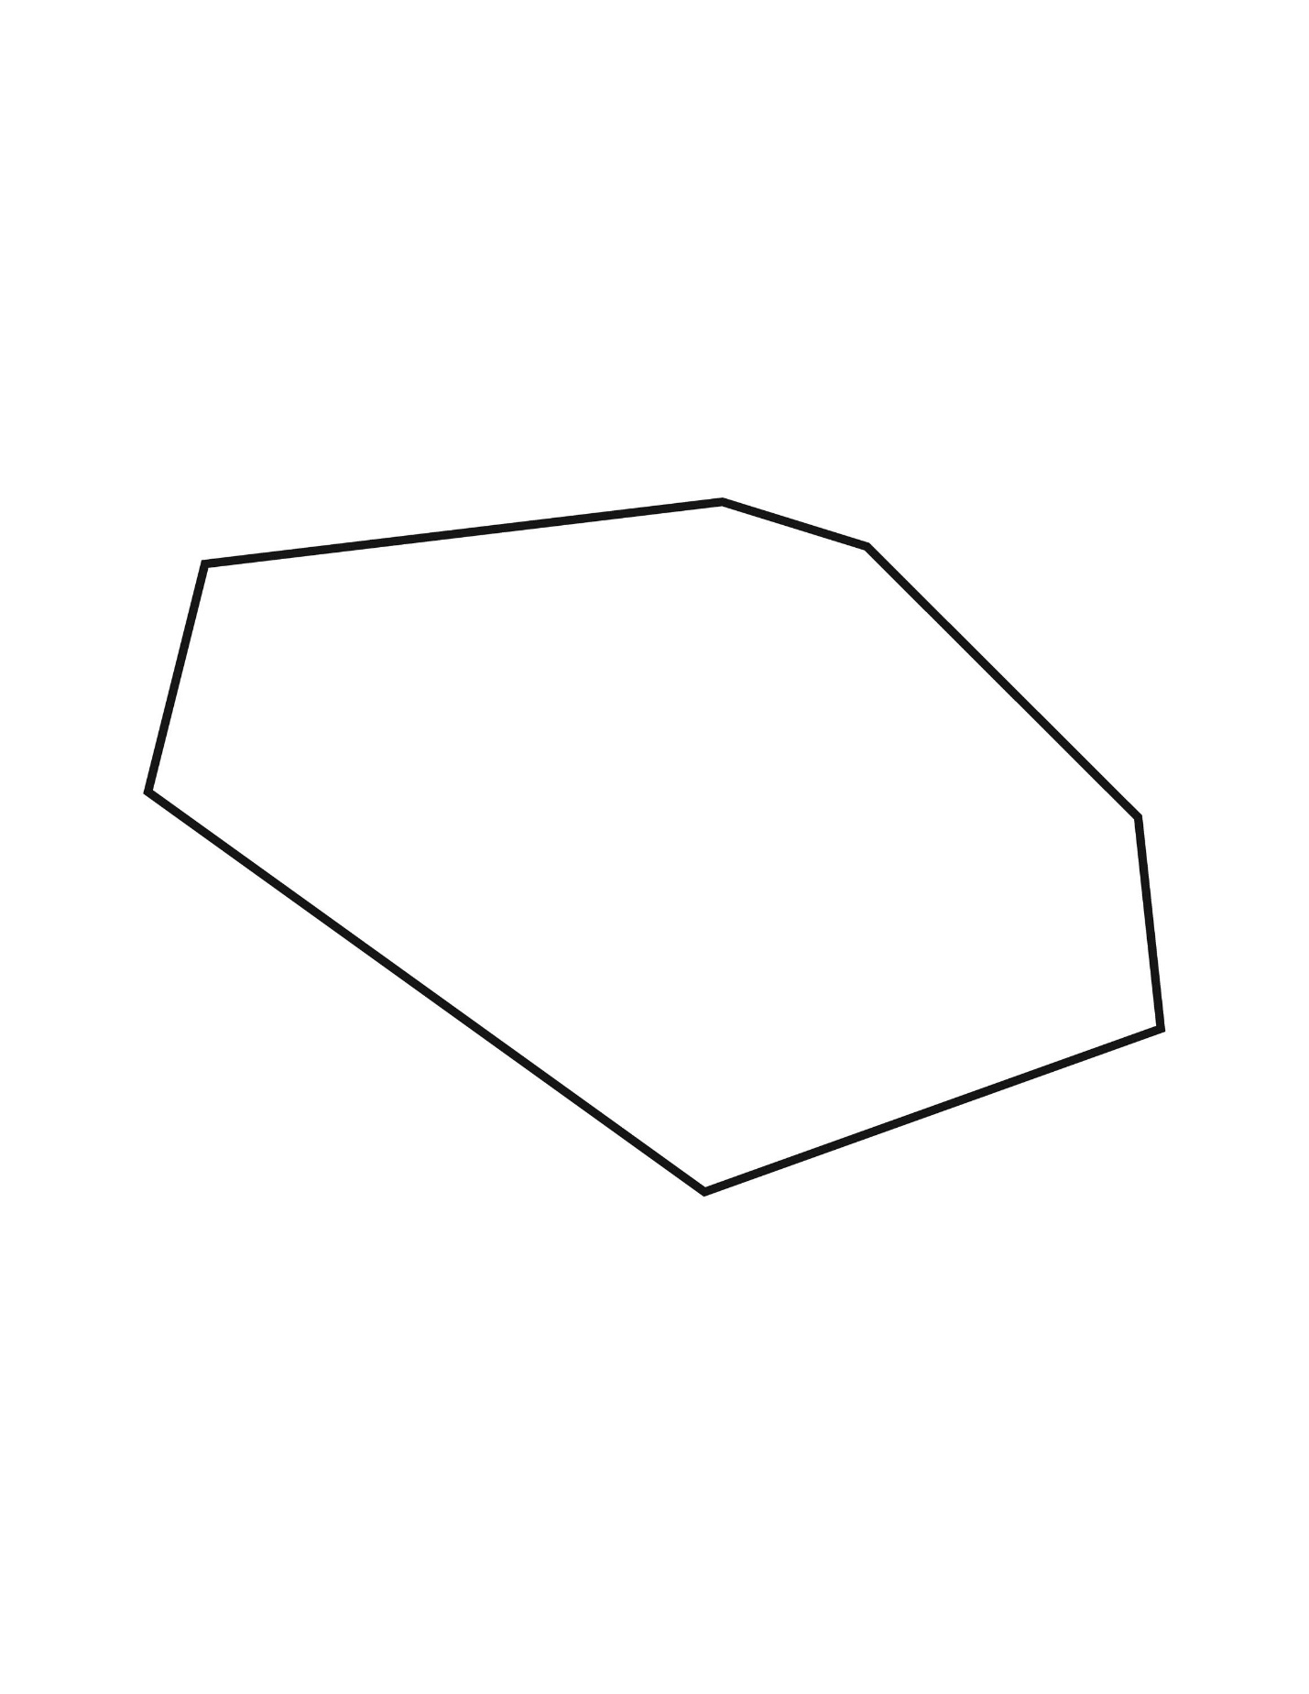
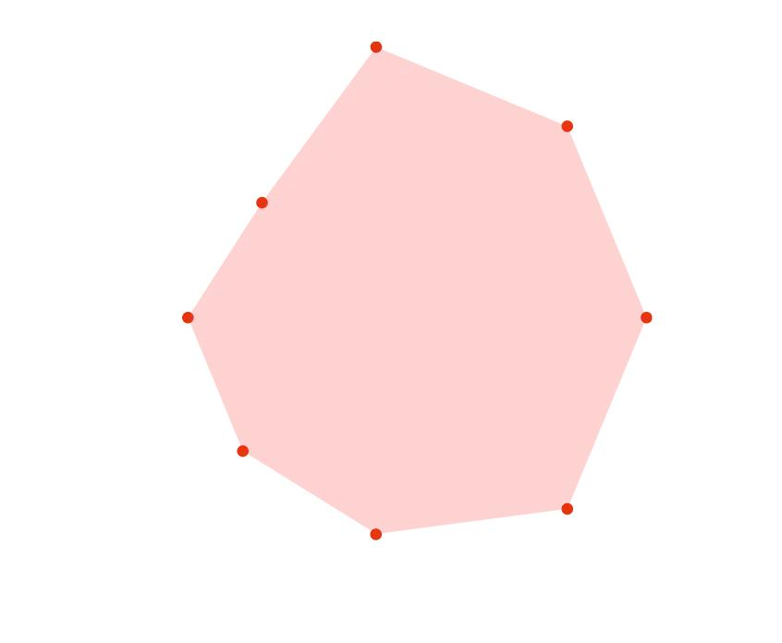
Definition
An asymmetric heptagon is a heptagon that has:
- no line of reflection symmetry;
- no non-trivial rotational symmetry.
Its shape does not map onto itself through any non-trivial symmetry operation.

Interior Angle Sum
# Source: AI Source: Provided by: [Data Path: Persons Table -> ID Column: 1, Name_En Column: Motasem Essam] -> From: [ChatGPT] on [7/25/2026]
For an $n$-sided polygon:
$$\boxed{\left(n-2\right)×{180}^{∘}}$$
For a heptagon:
$$\left(7-2\right)×{180}^{∘} \\ 5×{180}^{∘} \\ \boxed{{900}^{∘}}$$
Therefore:
$$\boxed{∠A+∠B+∠C+∠D+∠E+∠F+∠G={900}^{∘}}$$

Regular Heptagon Angles
# Source: AI Source: Provided by: [Data Path: Persons Table -> ID Column: 1, Name_En Column: Motasem Essam] -> From: [ChatGPT] on [7/25/2026]
For a regular heptagon, all seven interior angles are equal:
$$\frac{{900}^{∘}}{7} \\ \boxed{\text{Each interior angle}≈{128.57}^{∘}}$$
Each exterior angle is:
$${180}^{∘}-\frac{{900}^{∘}}{7} \\ \boxed{\frac{{360}^{∘}}{7}≈{51.43}^{∘}}$$

Number of Diagonals
# Source: AI Source: Provided by: [Data Path: Persons Table -> ID Column: 1, Name_En Column: Motasem Essam] -> From: [ChatGPT] on [7/25/2026]
The number of diagonals of an $n$-sided polygon is:
$$\boxed{\frac{n\left(n-3\right)}{2}}$$
For a heptagon:
$$\frac{7\left(7-3\right)}{2} \\ =\frac{7\left(4\right)}{2} \\ \boxed{14}$$
Therefore, a heptagon has:
$$\boxed{14\text{ diagonals}}$$
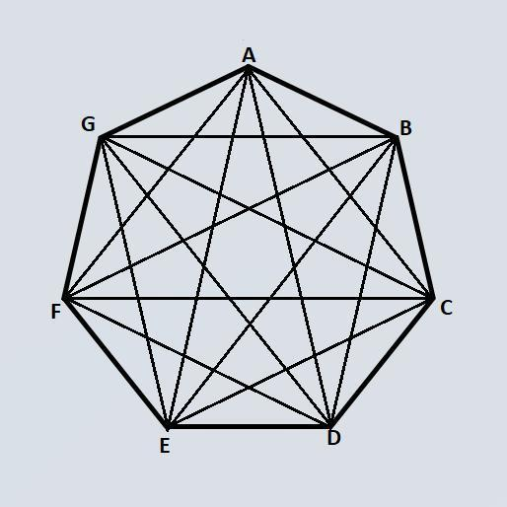
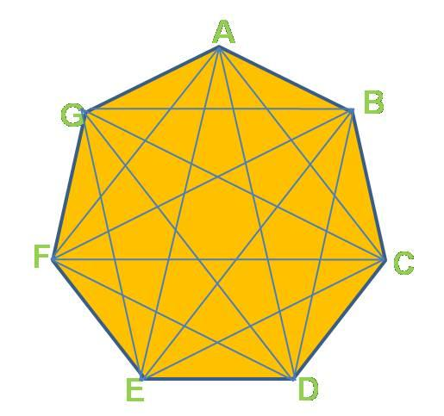
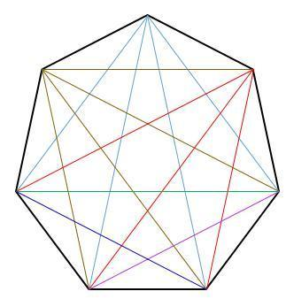

Diagonal Structure
# Source: AI Source: Provided by: [Data Path: Persons Table -> ID Column: 1, Name_En Column: Motasem Essam] -> From: [ChatGPT] on [7/25/2026]
From one vertex of a heptagon, the number of diagonals that can be drawn is:
$$n-3$$
Therefore:
$$7-3=\boxed{4}$$
Each vertex has four diagonals originating from it.
Counting them from all seven vertices:
$$7\left(4\right)=28$$
Each diagonal is counted twice, so:
$$\frac{28}{2}=\boxed{14}$$

Triangulation
# Source: AI Source: Provided by: [Data Path: Persons Table -> ID Column: 1, Name_En Column: Motasem Essam] -> From: [ChatGPT] on [7/25/2026]
A convex heptagon can be divided into:
$$n-2$$
triangles.
Therefore:
$$7-2=\boxed{5}$$
triangles can be formed by drawing diagonals from one vertex.
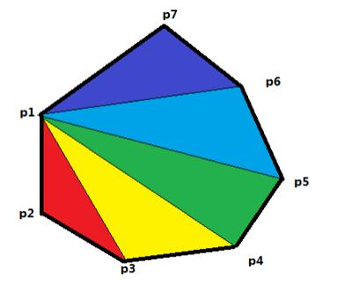
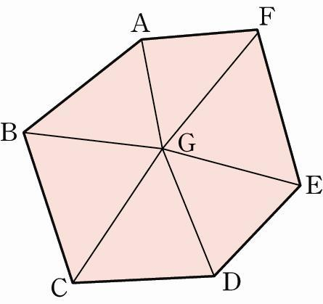
This also explains the interior-angle sum:
$$5×{180}^{∘}=\boxed{{900}^{∘}}$$

Regular Heptagon Measurements
# Source: AI Source: Provided by: [Data Path: Persons Table -> ID Column: 1, Name_En Column: Motasem Essam] -> From: [ChatGPT] on [7/25/2026]
Let the side length be $a$.
Perimeter
$$\boxed{P=7a}$$
Interior Angle
$$\boxed{\frac{{900}^{∘}}{7}≈{128.57}^{∘}}$$
Exterior Angle
$$\boxed{\frac{{360}^{∘}}{7}≈{51.43}^{∘}}$$
Central Angle
$$\boxed{\frac{{360}^{∘}}{7}≈{51.43}^{∘}}$$
Area
For a regular polygon:
$$A=\frac{1}{2}Pr$$
where $r$is the apothem.
Therefore, for a regular heptagon:
$$\boxed{A=\frac{1}{2}\left(7a\right)r}$$
or:
$$\boxed{A=\frac{7}{2}ar}$$

Example 1 — Interior Angle Sum
# Source: AI Source: Provided by: [Data Path: Persons Table -> ID Column: 1, Name_En Column: Motasem Essam] -> From: [ChatGPT] on [7/25/2026]
Find the sum of the interior angles of a heptagon.
$$\left(7-2\right)×{180}^{∘} \\ \boxed{{900}^{∘}}$$

Example 2 — Regular Heptagon
# Source: AI Source: Provided by: [Data Path: Persons Table -> ID Column: 1, Name_En Column: Motasem Essam] -> From: [ChatGPT] on [7/25/2026]
Find each interior angle of a regular heptagon.
$$\frac{{900}^{∘}}{7} \\ \boxed{{\frac{900}{7}}^{∘}≈{128.57}^{∘}}$$

Example 3 — Missing Angle
# Source: AI Source: Provided by: [Data Path: Persons Table -> ID Column: 1, Name_En Column: Motasem Essam] -> From: [ChatGPT] on [7/25/2026]
Suppose six interior angles of a heptagon are:
$${120}^{∘}, {130}^{∘}, {125}^{∘}, {140}^{∘}, {115}^{∘}, {135}^{∘}$$
Their sum is:
$$120+130+125+140+115+135={765}^{∘}$$
The total interior-angle sum is ${900}^{∘}$.
Therefore:
$$x={900}^{∘}-{765}^{∘} \\ \boxed{x={135}^{∘}}$$

Classification Summary
# Source: AI Source: Provided by: [Data Path: Persons Table -> ID Column: 1, Name_En Column: Motasem Essam] -> From: [ChatGPT] on [7/25/2026]
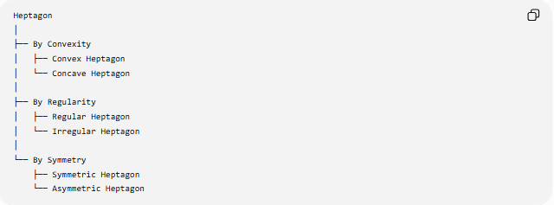
Heptagon
│
├── By Convexity
│ ├── Convex Heptagon
│ └── Concave Heptagon
│
├── By Regularity
│ ├── Regular Heptagon
│ └── Irregular Heptagon
│
└── By Symmetry
├── Symmetric Heptagon
└── Asymmetric Heptagon
These classifications can overlap.
For example:
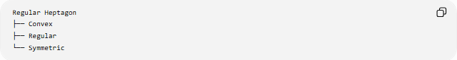
Regular Heptagon
├── Convex
├── Regular
└── Symmetric
while another heptagon could be:
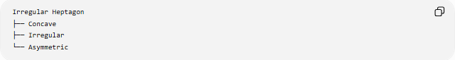
Irregular Heptagon
├── Concave
├── Irregular
└── Asymmetric

Relationship to Other Polygons
# Source: AI Source: Provided by: [Data Path: Persons Table -> ID Column: 1, Name_En Column: Motasem Essam] -> From: [ChatGPT] on [7/25/2026]
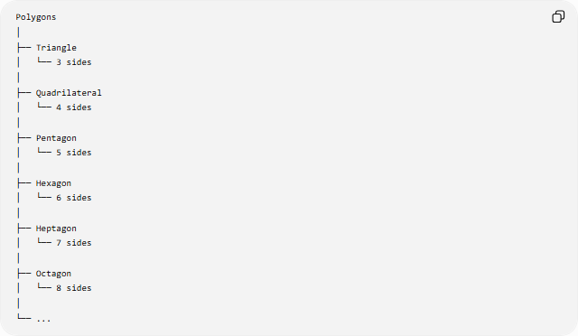
Polygons
│
├── Triangle
│ └── 3 sides
│
├── Quadrilateral
│ └── 4 sides
│
├── Pentagon
│ └── 5 sides
│
├── Hexagon
│ └── 6 sides
│
├── Heptagon
│ └── 7 sides
│
├── Octagon
│ └── 8 sides
│
└── ...

Key Properties
# Source: AI Source: Provided by: [Data Path: Persons Table -> ID Column: 1, Name_En Column: Motasem Essam] -> From: [ChatGPT] on [7/25/2026]
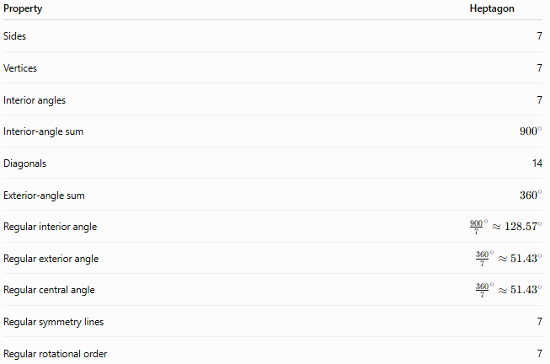
Property | Heptagon
Sides | 7
Vertices | 7
Interior angles | 7
Interior-angle sum | $${900}^{∘}$$
Diagonals | 14
Exterior-angle sum | $${360}^{∘}$$
Regular interior angle | $${\frac{900}{7}}^{∘}≈{128.57}^{∘}$$
Regular exterior angle | $${\frac{360}{7}}^{∘}≈{51.43}^{∘}$$
Regular central angle | $${\frac{360}{7}}^{∘}≈{51.43}^{∘}$$
Regular symmetry lines | 7
Regular rotational order | 7

Conclusion
# Source: AI Source: Provided by: [Data Path: Persons Table -> ID Column: 1, Name_En Column: Motasem Essam] -> From: [ChatGPT] on [7/25/2026]
A heptagon is a polygon with exactly seven sides and seven vertices.
Its fundamental properties are:
$$\boxed{7\text{ sides}} \\ \boxed{7\text{ vertices}} \\ \boxed{{900}^{∘}\text{ interior-angle sum}} \\ \boxed{14\text{ diagonals}}$$
A regular heptagon has seven equal sides, seven equal interior angles of approximately ${128.57}^{∘}$, seven lines of symmetry, and rotational symmetry of order $7$.

